CS 340 Project Two READ ME

Brandon Gallagher

CS 340: Client/Server Development

Professor Sean Morris

August 17, 2024

This Grazioso Salvare Dashboard is a python project designed to help animal shelters and users alike easily locate animals within the local animal shelters. Specifically, Grazioso Salvare will be using this framework to look for optimal training dogs for search and rescue missions. This dashboard utilizes mongoDB to consistently update the animal database for the user. This dashboard features a geolocation map, a interactive data table allowing users to filter animals, and a pie chart of the filtered data.

Project Structure:

Project Dashboard.ipynb - This houses the main jupyter code

Python Project BG.py - this houses the python CRUD module

Logo.png - this is the Grazioso Salvare logo

README – The updated read me file

Requirements:

You will need to install:

* Python
* MongoDB
* The required CRUD and Jupyter files

Once the files have been allocated and are working correctly you can launch the Jupyter file to connect to the database in mongoDB and from there you have access to the animals within the animal shelters. Users can then filter through and look for any animal the shelters might have on hand.

CS 340 Screenshots

1. 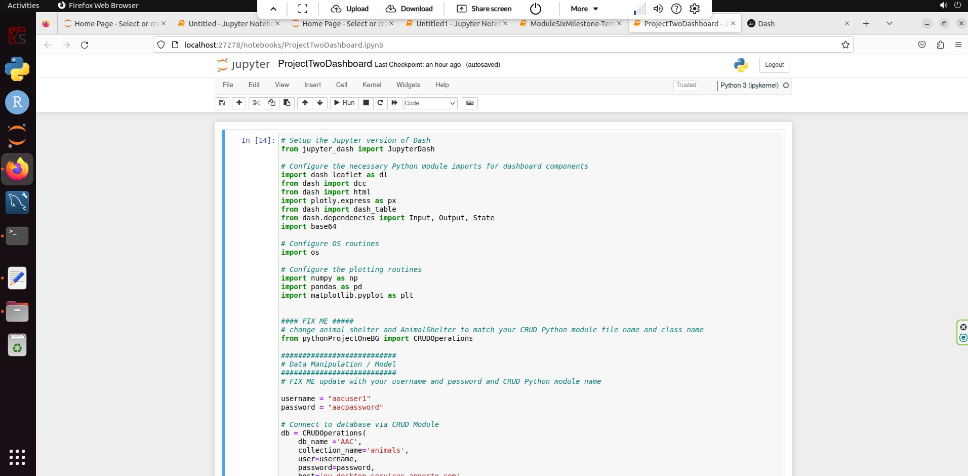
2. 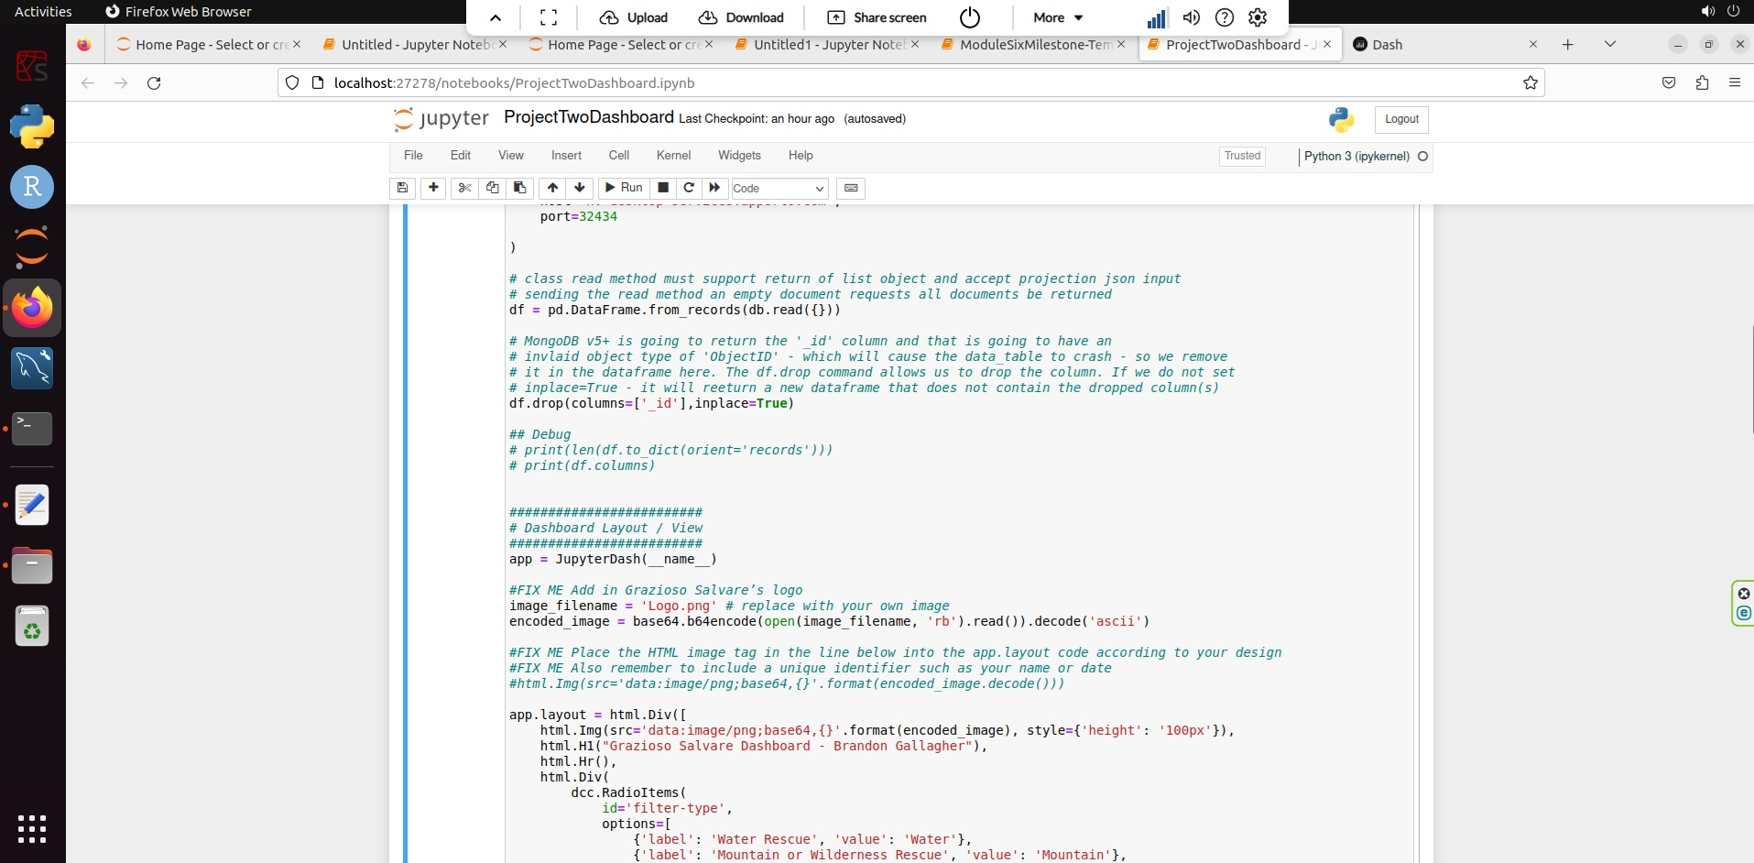
3. 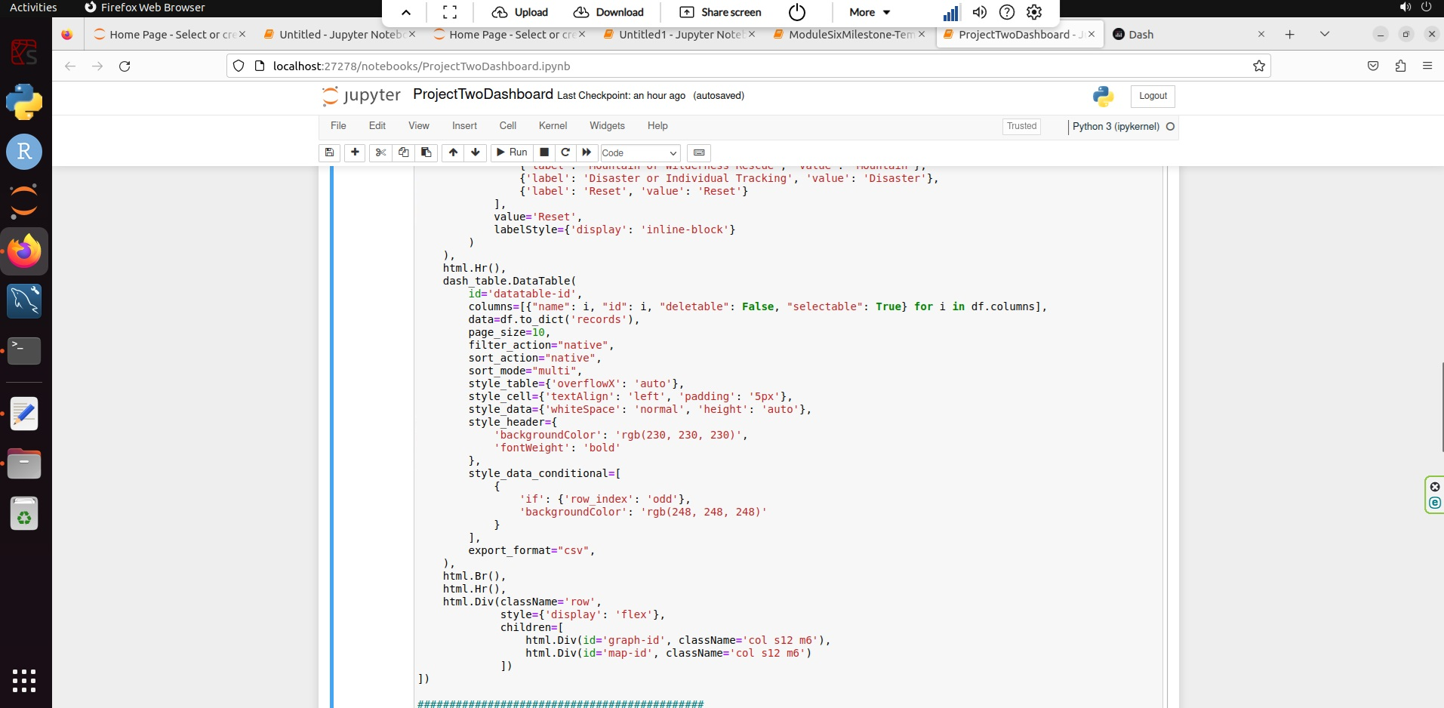
4. 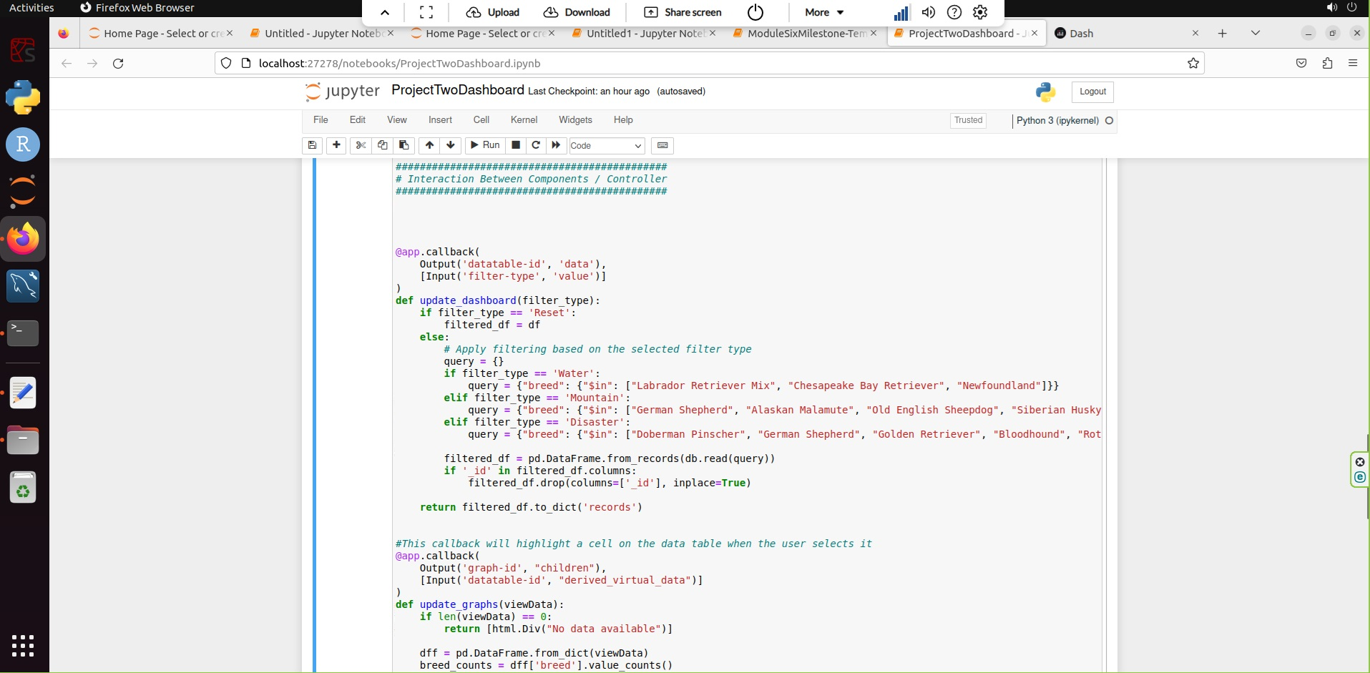
5. 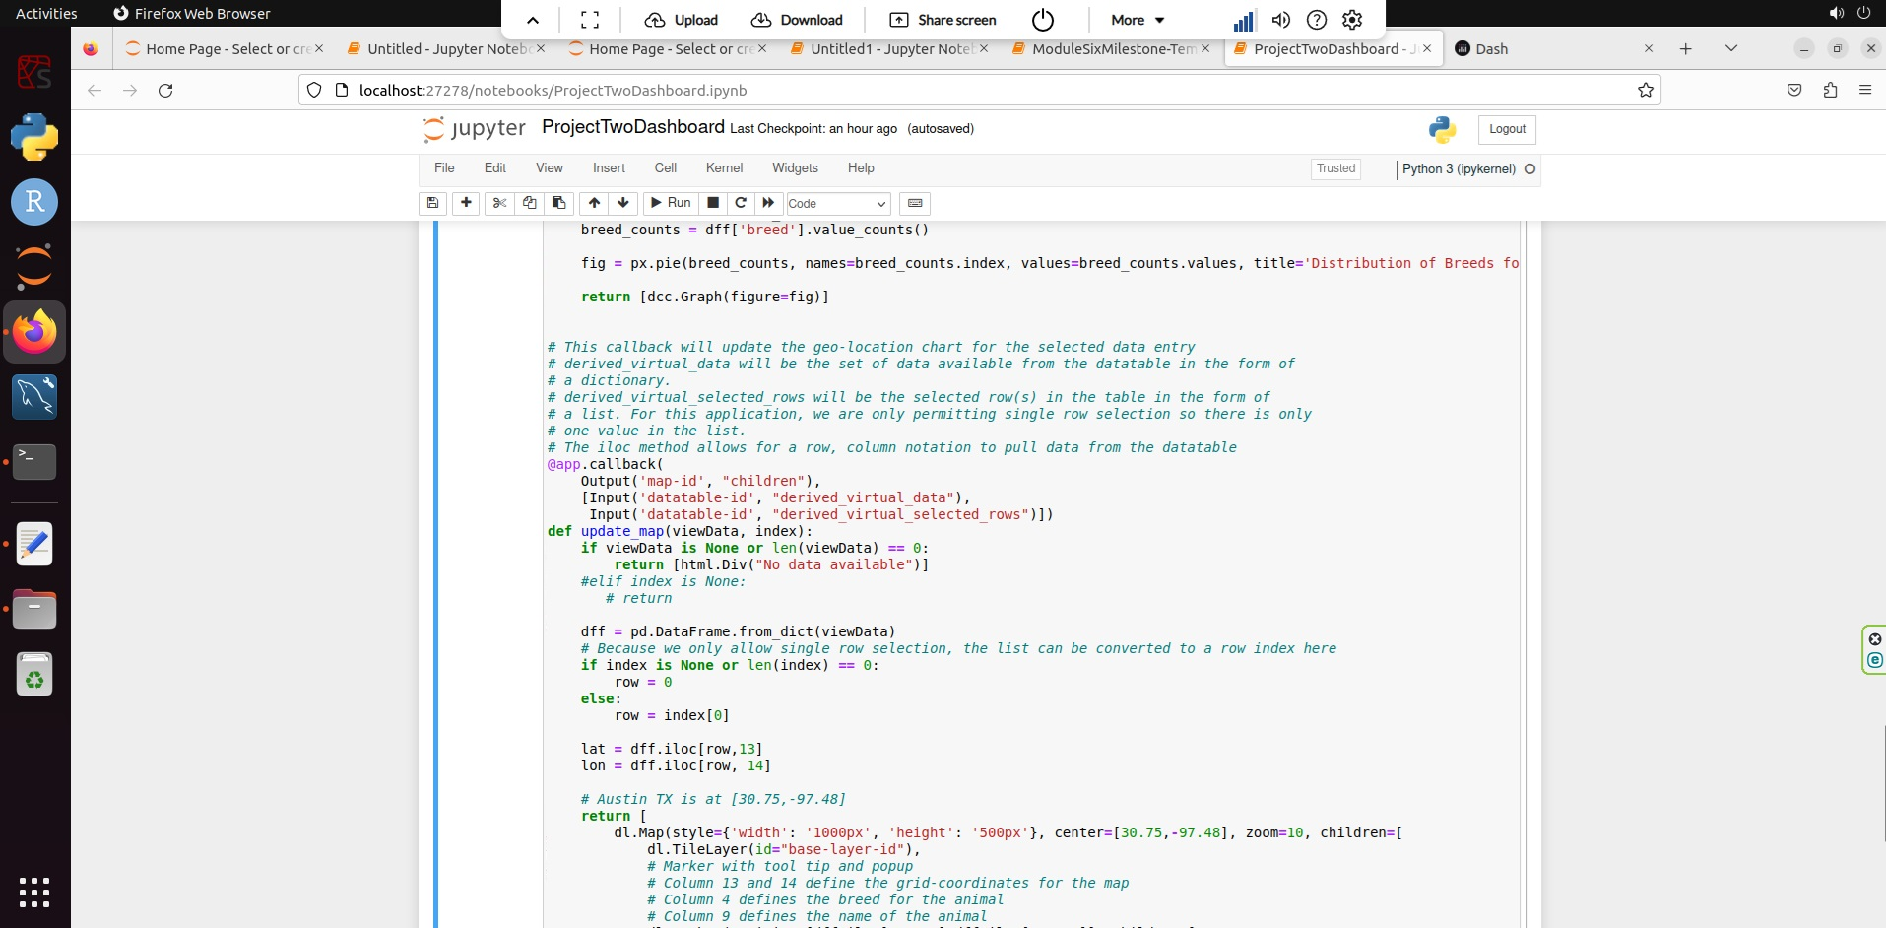
6. 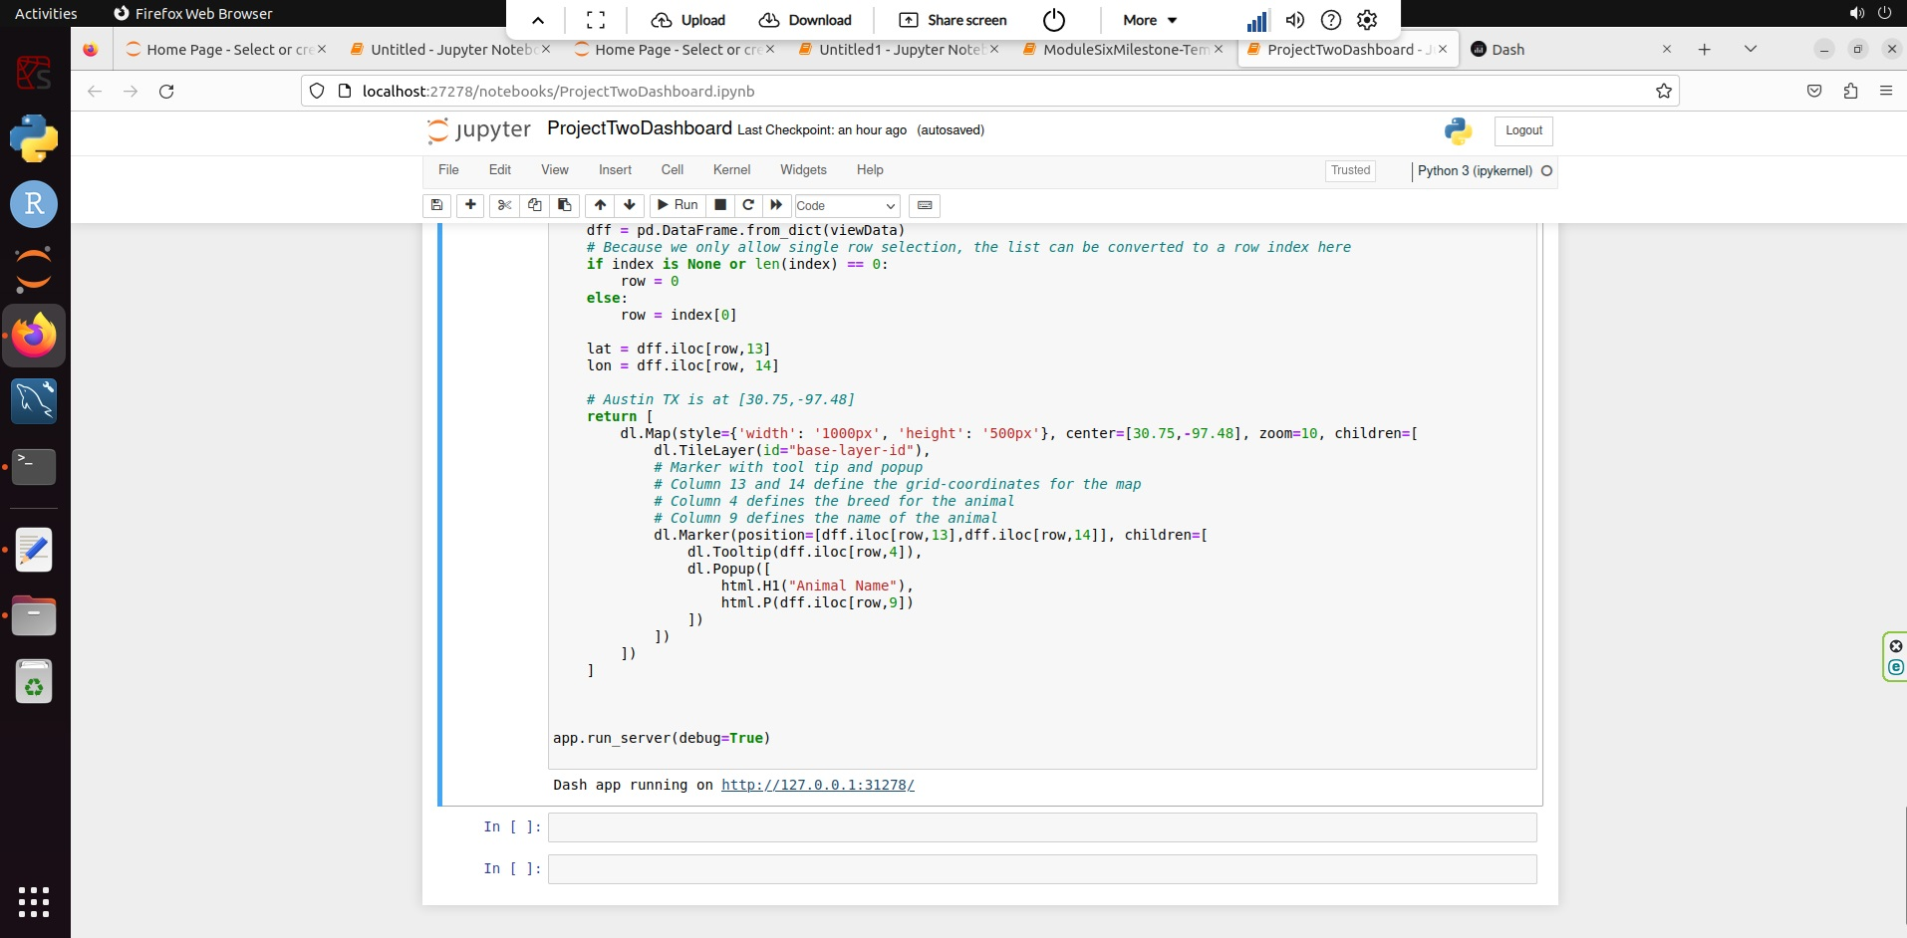
7. 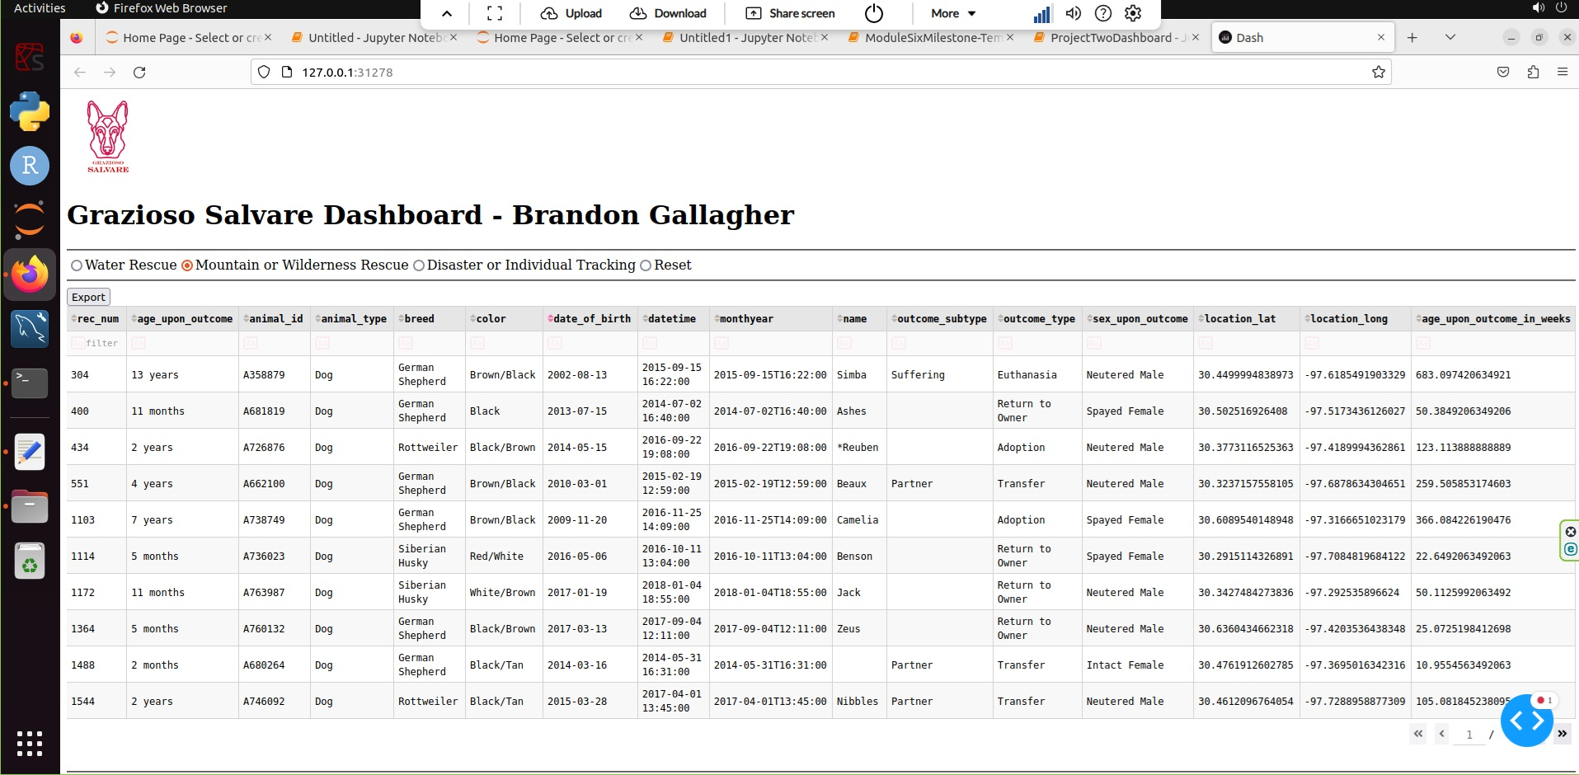
8. 